Scenario:

I am the IT administrator for a small corporate network. An employee in Marketing Group C is setting up a virtualization environment for software development. To make the system easier to use, they have requested dual monitors. I need to upgrade the Marketing6 computer to support dual monitors. I have purchased a second monitor and placed it in the Workspace. The video card in the computer currently only supports a single monitor, so I will need to upgrade the video card to support dual monitors.

In this scenario, my task is to:

* Select and install a video card that provides I with dual-monitor support for both monitors using a digital connection to the video card (When installing the video card, connect the PCIe power connector to the video card).

*Figure 1: Video Adapter, DVI, HDMI, Crossfire, PCIe(16x)*

* Connect the left monitor to the newly installed video card using an HDMI cable. The new monitor is already plugged into the surge protector. Connect the original monitor to the new video card using the DVI-D cable.

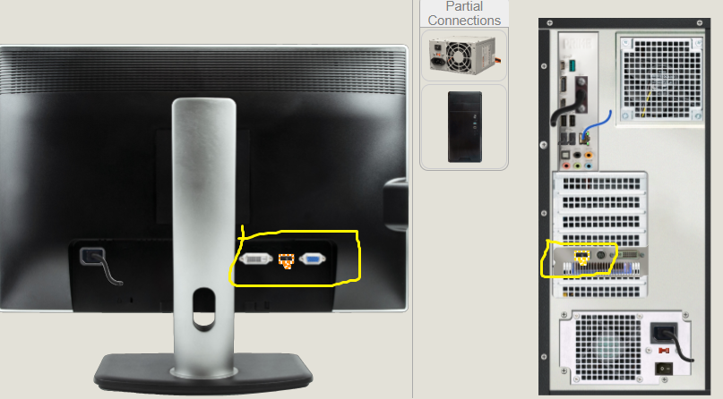

*Figure 2 : Using HDMI cable to connect new monitor to new video card*

* Turn on the computer. Turn on the new monitor.
* Make sure that ***Extend these displays***is selected.

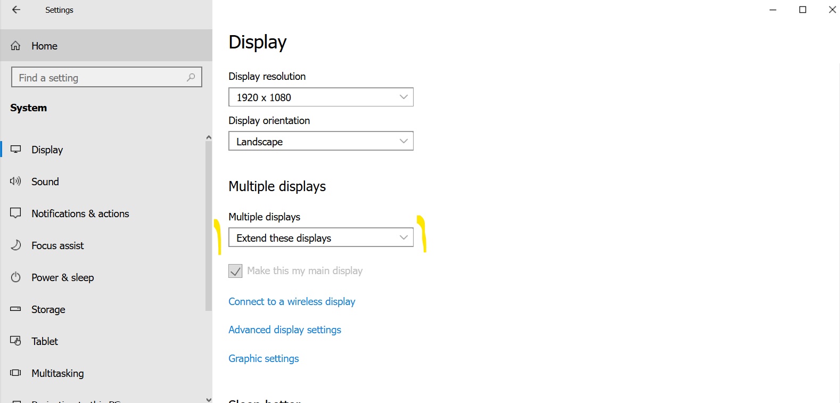

*Figure 3: Multiple displays configuration*

*Figure 4: Display settings*

* Configure the display properties to show the Start menu and taskbar on the left monitor (new monitor).

*Figure 5: Choose main display*

* Configure the relationship of the two monitors to reflect the physical placement of both monitors with the new Monitor 2 on the left as the main display.

*Figure 6: Make the new Monitor 2 on the left as the main display*